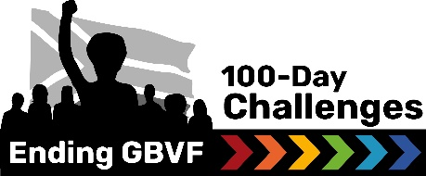

Guide for writing a press release.

A media release is a great way to pitch a story to a journalist, editor or anyone who is sitting within a media role. A well written media release will earn you media attention, published articles, and hopefully invitations for broadcast interviews (radio and television). Once a media release is drafted, it is distributed via email to a database of journalists, editors and programme managers. Those who are interested will pick up the media release as a story that will be published. In many instances, when a media release is published, the article will not change a lot, it will only differ in structure, heading and minor wording changes.
Please follow this guide before working on a media release.
TOP TIPS:
- A media release is written in third person; for example: For their 100-Day Challenge, Maluti TVET conducted targeted surveys on anti-Bully, sexual reproduction, and GBVF Surveys to determine risk factors. The number of students reporting they had experienced bullying dropped by 78%, which is attributed to the increase in GBVF and anti-bullying awareness sessions and campaigns targeting both students and staff.
- The media release should be between 400 to 700 words. It should not exceed 800 words.
- It should be factual and contain references to any statistics or figures that are included.
- The main key messages (most important points) should be included in the opening paragraph.
- Context should be provided thereafter.
- The headline should be catchy and easy to understand.
- The media release should include quotes from those involved in the story.
- A call to action is a great way to end off a media release. This is a way to entice the reader to engage with the organisation in some way.
- It should always include the date of distribution (when it is going to be sent to media).
- The media release should include links to more information (website or social media)
Formatting a quote is a media release:
“Text: insert quote in first person,” says Name and Surname, [persons title] of [Entity name].
Please note that the first time the person is quoted, you will need to write out their full name, title and entity they work for. Thereafter you can refer to their surname only to close off the quote.
Examples
First time quoted: "The training that took place is the first step in equipping leaders to drive change in a fast-paced, results-driven environment," says Nomgqibelo Mdlalose, Movement Navigator for the End GBVF 100-Day Challenges.
Second time quoted: "This initiative is about moving from intention to impact. With each Challenge, we are strengthening South Africa’s capacity to respond to GBVF in ways that are immediate, community-driven, and sustainable," adds / says Mdlalose.

Please refer to the next page for the press release structure:

[Insert logo]
Insert Title Here

RELEASE DATE: [Insert date]
[If there is an image available, insert if here]
Image source:
Caption: Insert caption directly below image (third person description of image content)
The first paragraph is the into paragraph. It should contain the most important key messages: Who? What? Why? When? Approximately 150 words. The first paragraph is in italics.
Follow of paragraph for context…. (+- 150 words)
“Add quote,” says xxx, title of personxxx. “Continuation of quote,” adds / says xx: [Please not that the first time the person is quoted, you will need to write out their full name, title and entity they work for. Thereafter you can refer to their surname only to close off the quote.]
For example:
Section titles (if the media release gets longer and needs to be packaged)
End off with a call-to-action. Explain to the reader how they can get involved in the story that they are reading about. This needs to be strong. Tell the reader how their help will make a difference.
Lastly… we will end off the media release with a way for reader to get more info.
For any media requests, contact:
Name: [contact person]
Email: [email]
Phone: [number]
Follow updates on social media: Facebook | Instagram | X | LinkedIn
ENDS

Please refer to the next page for an example of a past press release:

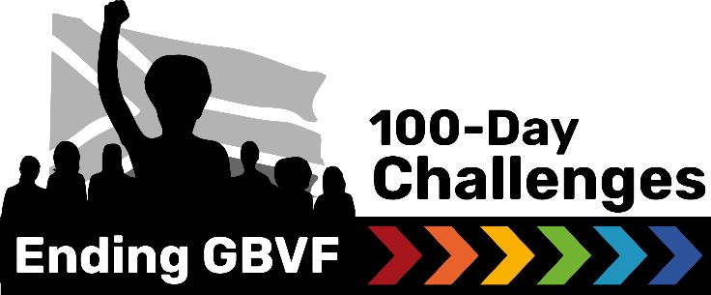
MEDIA RELEASE
Over 40 local system leaders training to facilitate End GBVF 100-Day Challenges in 2025

RELEASE DATE: 05 MARCH 2025
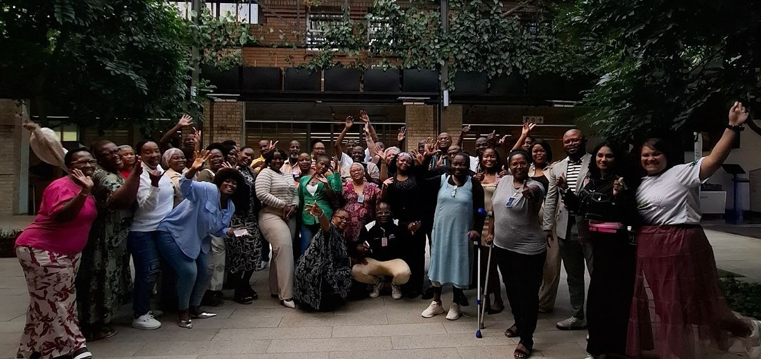
Last week (25 - 26 February 2025), over 40 local system leaders from municipalities and TVET colleges across South Africa were trained to organise, facilitate and support End Gender-Based Violence and Femicide (GBVF) 100-Day Challenges in 2025. This training marks the first of five cohorts that will take on the End GBVF 100-Day Challenges - scaling up the movement from 137 End GBVF 100-Day Challenges in 2024 to over 200 in 2025.
The End GBVF 100-Day Challenges are locally led initiatives that drive rapid, results-oriented action within three critical ecosystems: courts, municipalities, TVET colleges and Universities. These multi-stakeholder teams - which can include (include but are not limited to) representatives from SAPS, NGOs, social workers, traditional councils, local government departments, and GBVF survivors - work towards bold, time-bound goals aligned with the National Strategic Plan on GBVF.
Highlight from past End GBVF 100-Day Challenges:
Over the past three years, the End GBVF 100-Day Challenges have catalysed real, measurable change:
- 2022: 11 courts in South Africa reduced their backlogs of GBVF-related cases by 98%.
- 2023: In Frances Baard, the team focused on creating safer public spaces, leading to a 45.5% reduction in sexual offence cases.
- 2023: In Greater Tzaneen, GBVF case withdrawals dropped by 70%, while reporting increased by 37%.
- 2023: Seven new rapid response teams were launched in the Free State, and Mossel Bay established four new GBVF hotlines.
- 2024: 1,200 women participated in an economic empowerment initiative, with 60 women-led businesses securing funding and supply chain opportunities. Of 52 municipal contracts awarded, 39 went to women-owned businesses.
- 2024: Drakenstein Municipality trained 40 new student social workers and converted buildings into safe spaces for GBV victims.
- 2024: Waterberg District Municipality reached 5,900 people through awareness campaigns, contributing to a significant drop in GBV case withdrawal rates as survivors gained greater trust in the justice system.
Scaling Up South Africa’s Response to GBVF
South Africa remains in the grip of a GBVF crisis, with recent crime statistics revealing that over 53,000 sexual offences were reported in the 2023/24 period—equating to 145 incidents per day. Many suggest that the real figures are much higher due to underreporting. These statistics underscore the urgency of coordinated, high-impact interventions like the End GBVF 100-Day Challenges.
"The training that took place is the first step in equipping leaders to drive change in a fast-paced, results-driven environment," says Nomgqibelo Mdlalose, Movement Navigator for the End GBVF 100-Day Challenges. "This initiative is about moving from intention to impact. With each Challenge, we are strengthening South Africa’s capacity to respond to GBVF in ways that are immediate, community-driven, and sustainable."
A Growing, Multi-Sectoral Movement for Change
With over 200 End GBVF 100-Day Challenges planned for 2025, this initiative is rapidly expanding as one of the country’s largest and most action-oriented movements to end GBVF.
Court teams will focus on reducing case backlogs, lowering withdrawal rates, and accelerating case finalisation.
Municipal teams will create more safe spaces, enhance support services for survivors, empower women-led businesses, and reduce GBV incidents in high-risk areas.
TVET college teams will break the silence on GBV, increase survivor access to care and support, and drive deterrence on campuses by holding perpetrators accountable.
The momentum behind the End GBVF 100-Day Challenges continues to build, with growing support from the government, civil society, and the private sector. This movement proves that rapid, measurable change is possible - and that communities, when empowered, are at the forefront of ending GBVF in South Africa.
The training was done at Anglo American - Centre of Experiential Learning, which generously provided the participants with the venue, food and accommodation.
Follow these important developments on the 100-Day Challenges social media pages:
Instagram: https://www.instagram.com/endgbvf_100daychallenges/
Twitter: https://twitter.com/gbvf100days
Facebook: https://www.facebook.com/endgbvf100days

