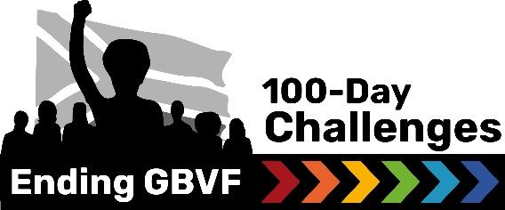

MEDIA RELEASE
[INSERT TITLE: e.g. (Entity Name) commits to a 100-Day Challenge sprint to strengthen response to gender-based violence and femicide (GBVF)

RELEASE DATE: [Insert date]
[Insert an image, with a caption. Suggested: Entity name is participating in a 100-Day Challenge to End GBVF. Insert name of people in the picture, attended the leadership training session, on *insert date to organise, facilitate and support the 100-Day Challenge in *insert entity]
South Africa remains in the grips of a gender-based violence and femicide crisis. Based on the most recent data released in late 2025, 19,387 cases were reported in just six months, averaging over 105 incidents per day. In many communities in South Africa, institutions remain under-resourced and overwhelmed with the prevalence of incidents. In light of this reality, [Entity name] has announced that it will be participating in the 100-Day Challenge to End GBVF, with a clear focus on [insert reason for participating / or focus area]
Over a 100-day period, the team will commit to an intensive sprint, while looking to collaborate with multiple stakeholders within [insert location] to address [insert main focus area].
The 100-Day Challenges to End GBVF are locally led initiatives that drive rapid, results-oriented action within three critical ecosystems: courts, municipalities, TVET colleges and Universities. These multi-stakeholder teams - which can include representatives from the South African Police Service (SAPS), NGOs, social workers, traditional councils, local government departments, and GBVF survivors - work towards bold, time-bound goals aligned with the National Strategic Plan on GBVF.
“[Insert a quote on the important / urgency of addressing your selected focus area through a 100-Day sprint that measures progress towards an ambitious goal],” says [insert name, role in institution and role in 100-Day Challenge]
A growing, multi-sectoral movement
With over 200 End GBVF 100-Day Challenges planned for 2026, this initiative is rapidly expanding as one of the country’s largest and most action-oriented movements to end GBVF.
Court teams will focus on reducing case backlogs, lowering withdrawal rates, and accelerating case finalisation. Municipal teams are aiming to create more safe spaces, enhance support services for survivors, empower women-led businesses, and reduce GBV incidents in high-risk areas. TVET college teams are looking to break the silence on GBV, increase survivor access to care and support, and drive deterrence on campuses by holding perpetrators accountable.
The momentum behind the End GBVF 100-Day Challenges continues to build, with growing support from the government, civil society, and the private sector. This movement proves that rapid, measurable change is possible - and that communities, when empowered, are at the forefront of ending GBVF in South Africa.
Building capacity with leadership
To prepare for their 100-Day Challenge [insert name of team coach] attended a training session for local system leaders to organise, facilitate and support the 100-Day Challenges to End GBVF in 2026. This training that took place on [insert date] marks the first of three clusters of system leaders that will take on the 100-Day Challenges in 2026.
“[Share what the team hopes the 100-Day Challenge can help improve for the community and victims/ survivors. Add a call for support.],” adds [Surname only].
END.
For any media requests, contact:
Name: [contact person]
Email: [email]
Phone: [number]
Follow updates on social media: Facebook | Instagram | X | LinkedIn

